**library_logo_200.gif**  BTR820 Summer 2021

**Let’s find an ebook using Library Search!**

**Get started:**

1. Go to the Computer Science and IT subject guide: <https://seneca.libguides.com/computerscience>
2. Click on the tab: **Books**
3. Click on **library search** under **Finding eBooks**.

**You can find eBooks using**[**library**](http://libcat.senecac.on.ca/vwebv/searchBasic?sk=en_US)[**search**](https://library.senecacollege.ca/)**or any of the following eBook databases:**

4. Type **java** in the Library Search box. Hit enter.

5. How many results did you get? **458590** That’s too many results!

**Begin to refine your results:**

1. Click **Show More** under **Content / Material Type**. Then click **Books**.
2. Under **Publication Date:** Type **2020 To 2023**. Click on **Refine.**

**Select an ebook:**

1.Click on the title of this ebook (approx. #6 in the list):

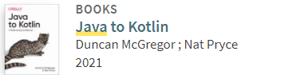

2.Select the database**: Safari Books Online**

3.Log in using your Seneca username and password.

4.How many chapters in this book? **16 Chapters**

Now you can read the ebook in your browser!

Congratulations! You completed the Library Search exercise for an electronic book.